STACK PROGRAM:

AIM:

To create stack using the linked list and doing the stack operation in it.

ALGORITHM:
· Initialize the stack by setting the top pointer to NULL and size to zero.
· Display the menu for push, pop, empty check, full check, and exit operations.
· Read the user’s choice from the keyboard.
· If the push option is selected, check whether the stack size has reached the maximum limit.
· Display stack overflow if the stack is full.
· Insert the element at the top of the stack and increment the size if the stack is not full.
· If the pop option is selected, check whether the stack is empty.
· Display stack underflow if the stack is empty.
· Remove the top element from the stack, display value, and decrement the size if the stack is not empty.
· Check whether the stack is empty and display the appropriate message when the empty option is selected.
· Check whether the stack is full and display the appropriate message when the full option is selected.
· Repeat the above steps until the exit option is selected.
PROGRAM:

/*
* Program to implement a stack using linked list
* Author: MUTHUGANESH S
* Date : 20/1/2026
* File : StackProgram.c
* retval: void
*/

// Include necessary headers
#include <stdio.h>
#include <stdlib.h>

// Define boolean values and stack size
#define TRUE 1
#define FALSE 0
#define STACK_SIZE 5

// Define the Node structure
typedef struct Node {
int Data;
struct Node* Next;
} Node;

// Define the Stack structure
typedef struct Stack {
Node* HeadNode;
int Size;
} Stack;

// Function to create a new node
Node* CreateNode(int Data){

Node* NewNode = (Node*)malloc(sizeof(Node));

if(NewNode == NULL){
printf("Memory allocation failed\n");
return NULL;
}

NewNode->Data = Data;
NewNode->Next = NULL;
return NewNode;
}

// Function to push an element onto the stack
void Push(Stack* MyStack, int Data){

Node* NewNode = CreateNode(Data);

if(NewNode == NULL){
printf("Stack Overflow\n");
return;
}

if(MyStack->Size == STACK_SIZE){
printf("Stack Overflow\n");
free(NewNode);
return;
}

MyStack->Size++;
NewNode->Next = MyStack->HeadNode;
MyStack->HeadNode = NewNode;
printf("Pushed element: %d\n", Data);
}

// Function to pop an element from the stack
void Pop(Stack* MyStack){

if(MyStack->HeadNode == NULL){
printf("Stack Underflow\n");
return;
}

Node* TempNode = MyStack->HeadNode;
MyStack->HeadNode = MyStack->HeadNode->Next;
MyStack->Size--;

printf("Popped element: %d\n", TempNode->Data);

free(TempNode);
}

// Function to check if the stack is empty
int IsEmpty(Stack* MyStack){
return MyStack->HeadNode == NULL;
}

// Function to check if the stack is full
int IsFull(Stack* MyStack){
return MyStack->Size == STACK_SIZE;
}

int main(void){
Stack MyStack;
MyStack.HeadNode = NULL;
MyStack.Size = 0;

int Value,Data;

printf("Menu:\n");
printf("1. Push\n");
printf("2. Pop\n");
printf("3. check Empty\n");
printf("4. check Full\n");
printf("5. Exit\n");

printf("Enter your choice: ");
scanf("%d", &Value);

while(Value != 5){
switch (Value)
{
case 1:
printf("Enter data to push: ");
scanf("%d", &Data);
Push(&MyStack, Data);
break;

case 2:
Pop(&MyStack);
break;

case 3:
if(IsEmpty(&MyStack)==TRUE){
printf("Stack is empty\n");
} else {
printf("Stack is not empty\n");
}
break;

case 4:
if(IsFull(&MyStack)==TRUE){
printf("Stack is full\n");
} else {
printf("Stack is not full\n");
}
break;

case 5:
exit(0);

default:
break;
}
printf("\nEnter your choice: ");
scanf("%d", &Value);
}

return 0;
}

OUTPUT:

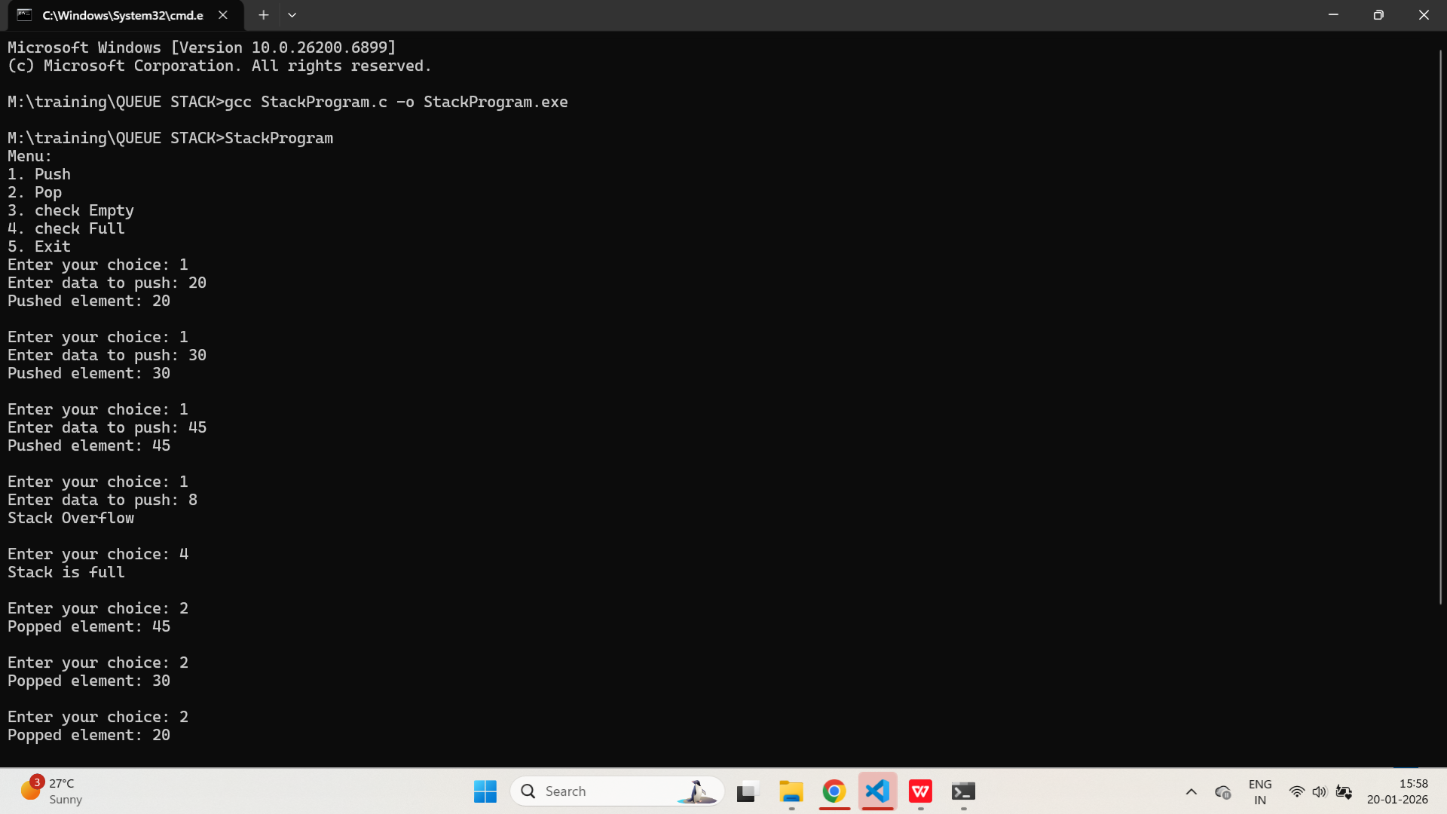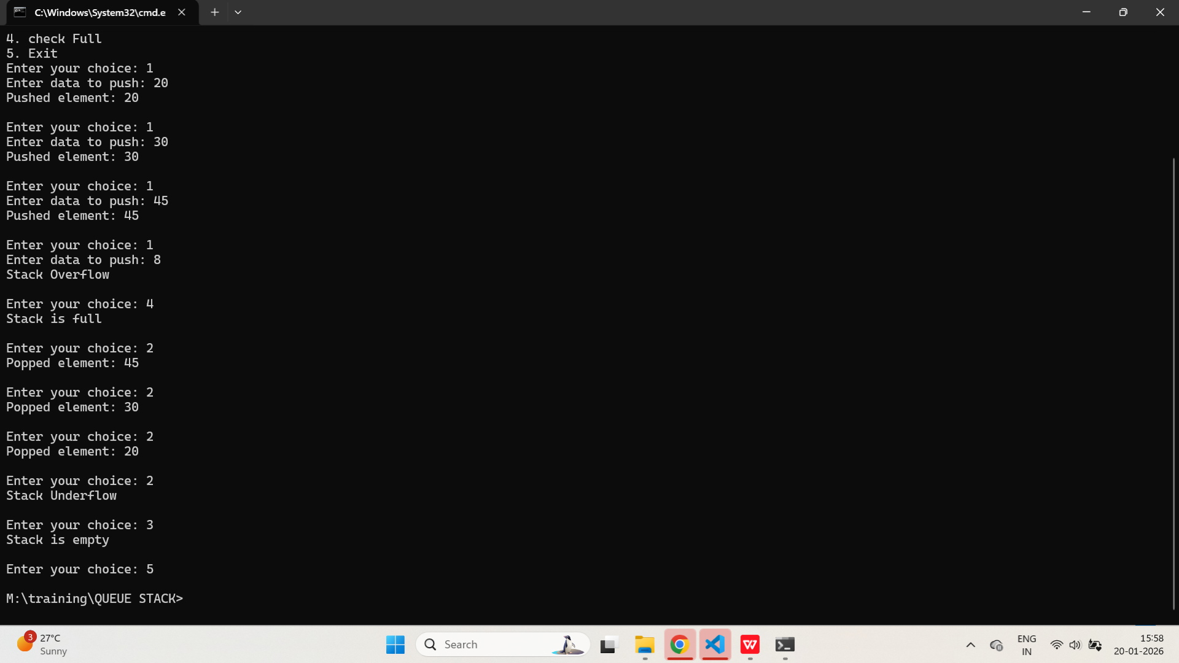

QUEUE PROGRAM

AIM:

To create a Queue using linked list and perform Queue functionalities.

ALGORITHM:
· Initialize the queue by setting the front and rear pointers to NULL and the size to zero.
· Display the menu for enqueue, dequeue, and exit operations.
· Read the user’s choice from the keyboard.
· If the enqueue option is selected, check whether the queue size has reached the maximum limit.
· Display queue overflow if the queue is full.
· Create a new node and insert the element at rear of the queue and increment the size if the queue is not full.
· If the dequeue option is selected, check whether the queue is empty.
· Display queue underflow if the queue is empty.
· Remove the elementfrom the front of queue,display value, and decrement size if the queue is not empty.
· Repeat the above steps based on the user’s choice until the exit option is selected.

PROGRAM:

/*
* Program to implement a Queue using linked list
* Author: MUTHUGANESH S
* Date : 20/1/2026
* File : QueueProgram.c
* retval: void
*/

// Include necessary headers
#include <stdio.h>
#include <stdlib.h>

// Define queue size
#define MAX_QUEUE_SIZE 4

// Define the Node structure
typedef struct Node {
int Data;
struct Node* Next;
} Node;

// Define the Queue structure
typedef struct Queue {
Node* Front;
Node* Rear;
int Size;
} Queue;

// Function to create a new node
Node* CreateNode(int Data){
Node* NewNode = (Node*)malloc(sizeof(Node));
if(NewNode == NULL){
printf("Memory allocation failed\n");
return NULL;
}
NewNode->Data = Data;
NewNode->Next = NULL;
return NewNode;
}

// Function to enqueue an element into the queue
void Enqueue(Queue* MyQueue, int Data){
if(MyQueue->Size == MAX_QUEUE_SIZE){
printf("Queue Overflow\n");
return;
}

Node* NewNode = CreateNode(Data);
if(NewNode == NULL){
printf("Memory allocation failed\n");
return;
}

if(MyQueue->Rear == NULL){
MyQueue->Front = MyQueue->Rear = NewNode;
}
else {
MyQueue->Rear->Next = NewNode;
MyQueue->Rear = NewNode;
}

MyQueue->Size++;
printf("Enqueued element: %d\n", Data);
}

// Function to dequeue an element from the queue
void Dequeue(Queue* MyQueue){

if(MyQueue->Size == 0){
printf("Queue Underflow\n");
return;
}

Node* TempNode = MyQueue->Front;
MyQueue->Front = MyQueue->Front->Next;

if(MyQueue->Front == NULL){
MyQueue->Rear = NULL;
}

MyQueue->Size--;
printf("Dequeued element: %d\n", TempNode->Data);
free(TempNode);
}

int main(void){

// Initialize the queue
Queue MyQueue;
MyQueue.Front = NULL;
MyQueue.Rear = NULL;
MyQueue.Size = 0;

printf("Queue Operations:\n");
printf("1. Enqueue\n");
printf("2. Dequeue\n");
printf("3. Exit\n");

int Value, Data;
printf("Enter your choice: ");
scanf("%d", &Value);

while(Value != 3){
switch(Value){

case 1:

printf("Enter data to enqueue: ");
scanf("%d", &Data);
Enqueue(&MyQueue, Data);
break;

case 2:

Dequeue(&MyQueue);
break;

default:

printf("Invalid choice\n");
break;

}

printf("\nEnter your choice: ");
scanf("%d", &Value);
}

return 0;
}
OUTPUT:

